**Assignment  
Advanced Python Major by Sachin Kamath**

**Importing the csv file**

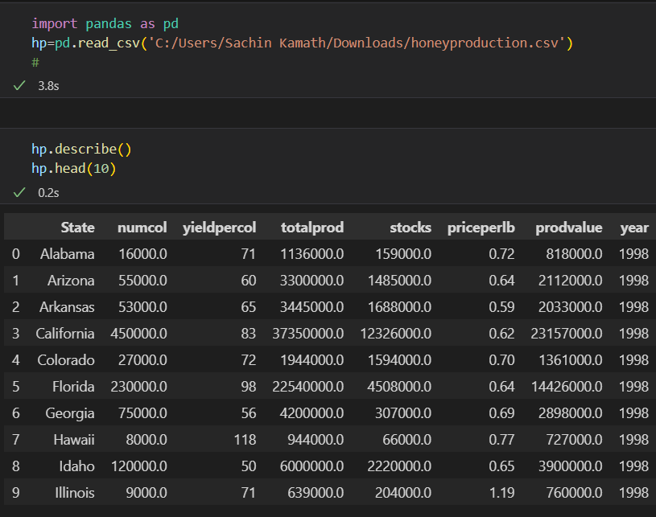

**1st Question**

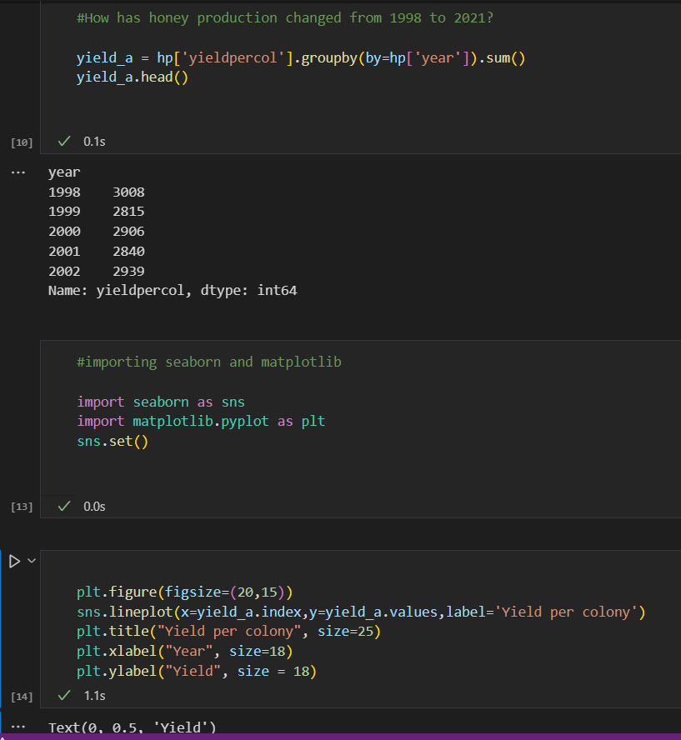

**Plot Image for Question 1**

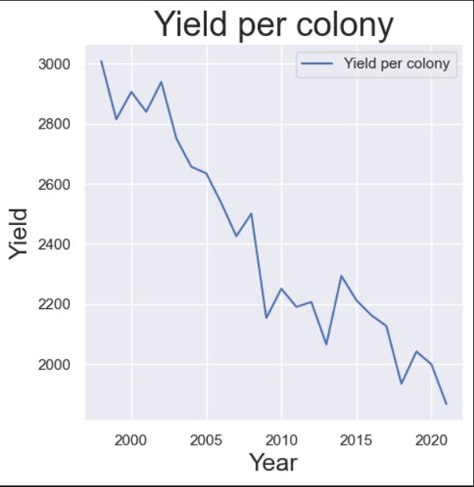

**-We see from the plot that the honey production has significantly decreased from 1998 to   
 2021.**

**- There was a slight increase between 2012 and 2015 but again it decreased**

**2nd Question**

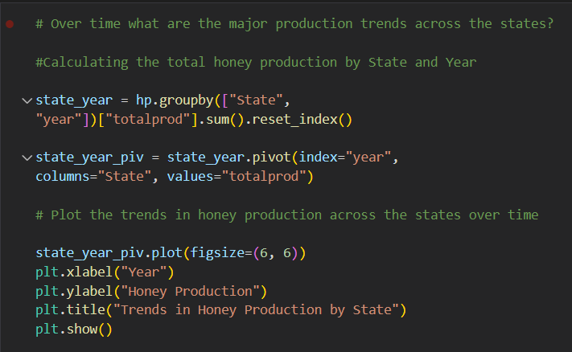

**Plot for 2nd Question**

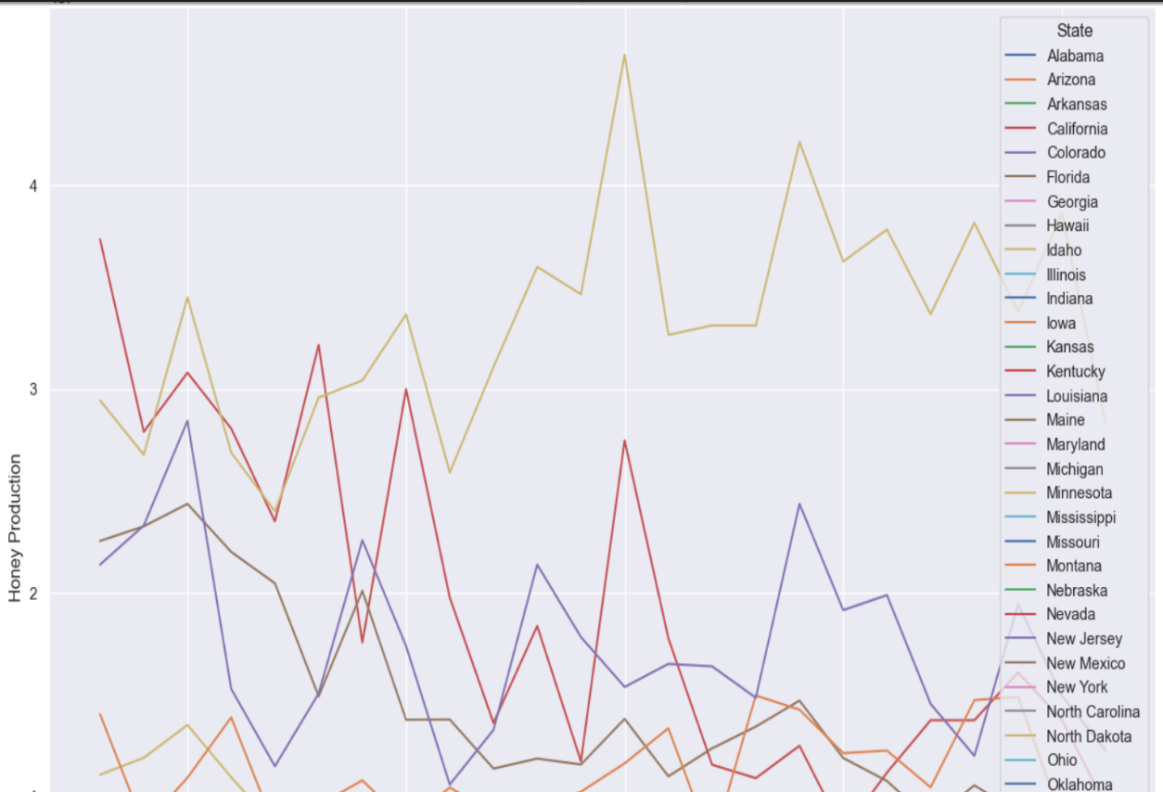

**Plot for 2nd Ques – Continuation**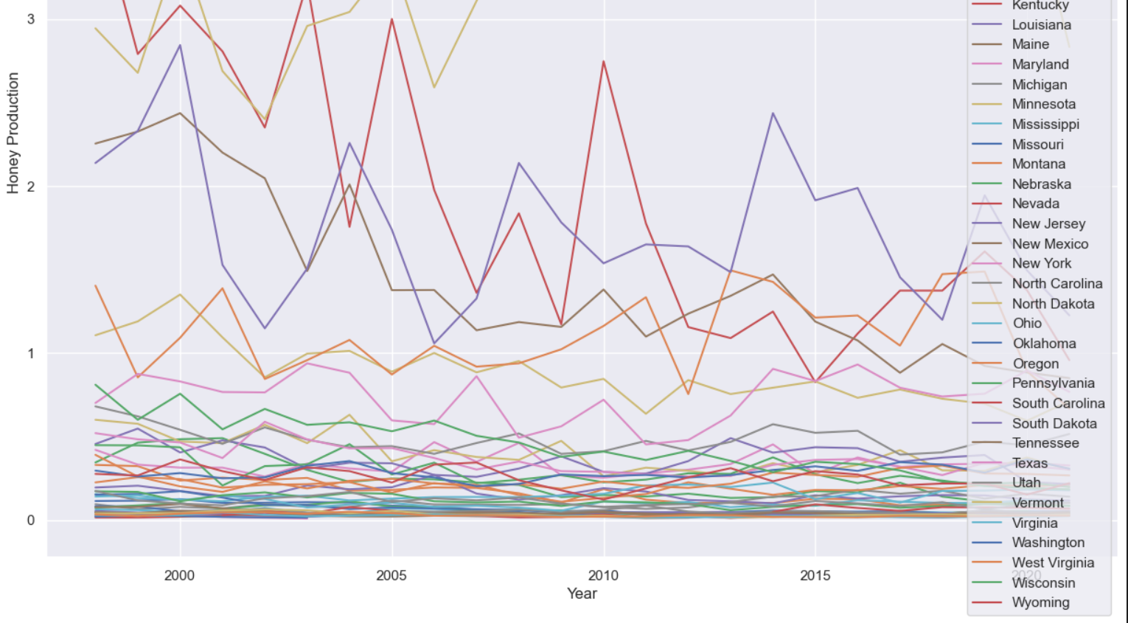

**3rd Question**

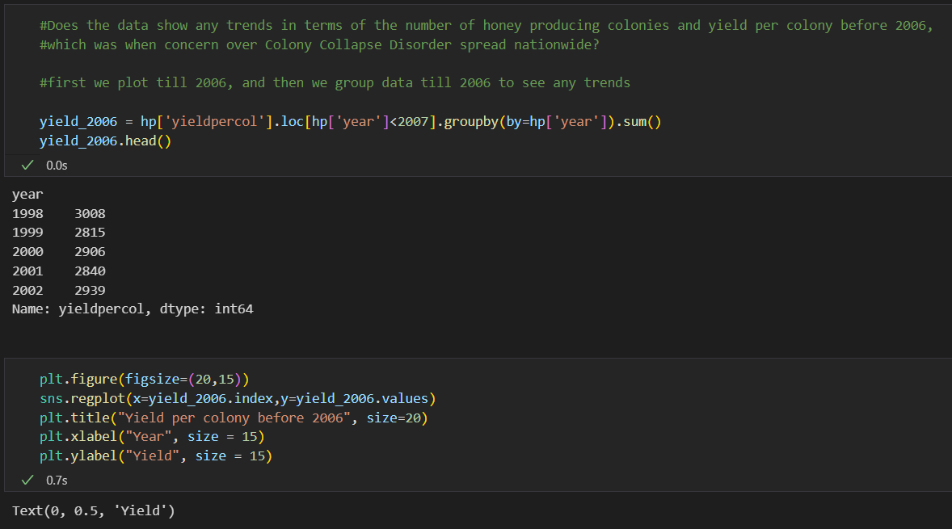

**Plot for 3rd Question**

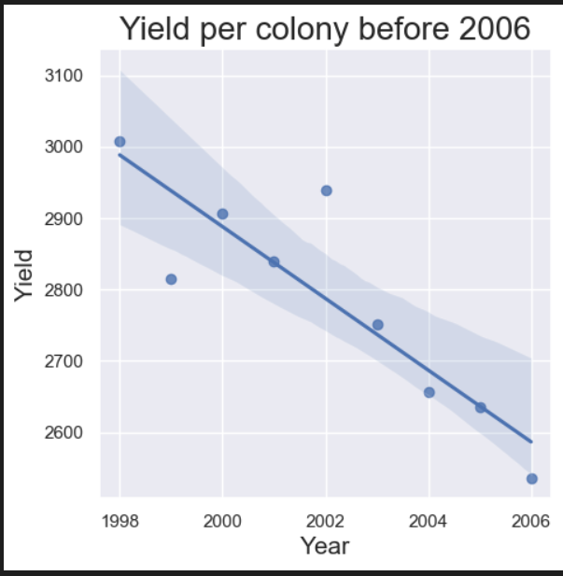

**Conclusion for Question 3**

Plotting the data point and fitting a linear regression in it using seaborn regplot reveals a substantial trend to drop.

**Question 4**

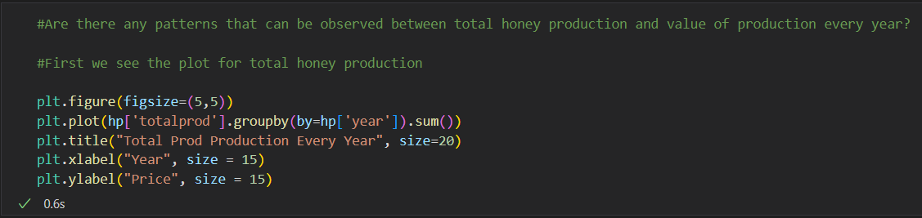

**First, we see the plot for total honey production**

**Plot for Total Production Every Year**

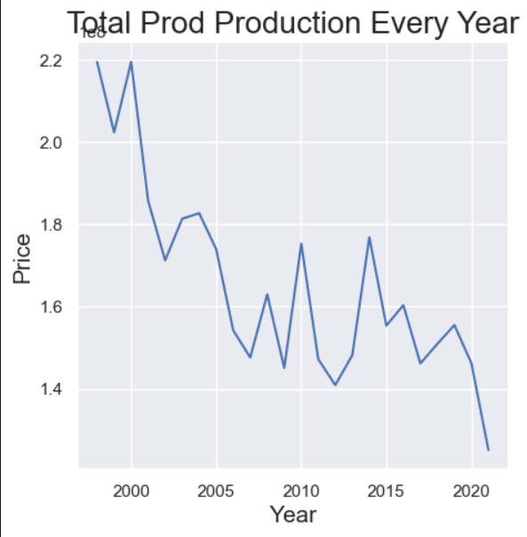

**Question 4   
  
Now we write the syntax to see the plot for Value of Production**

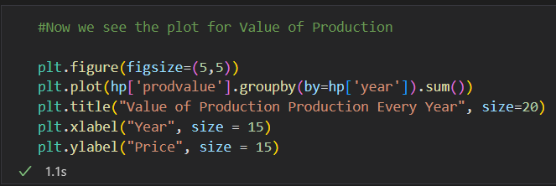

**Plot for Value of Production**

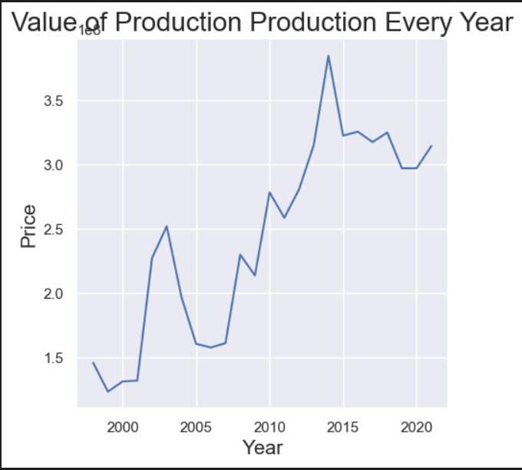

**Conclusion for Ques 4**

# From the plot we see that there has been a pattern in increase of total production and value of production

# The profits are more favourable towards lesser rate of production

**Question 5**

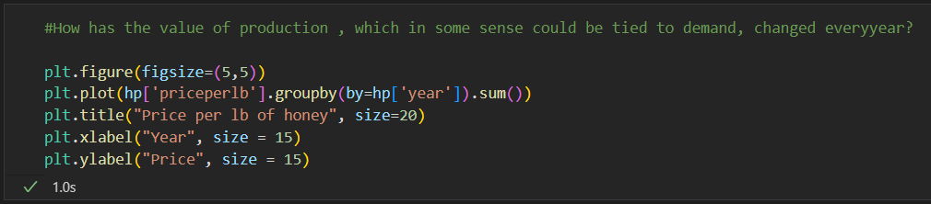

**Plot of Image for Question 5**

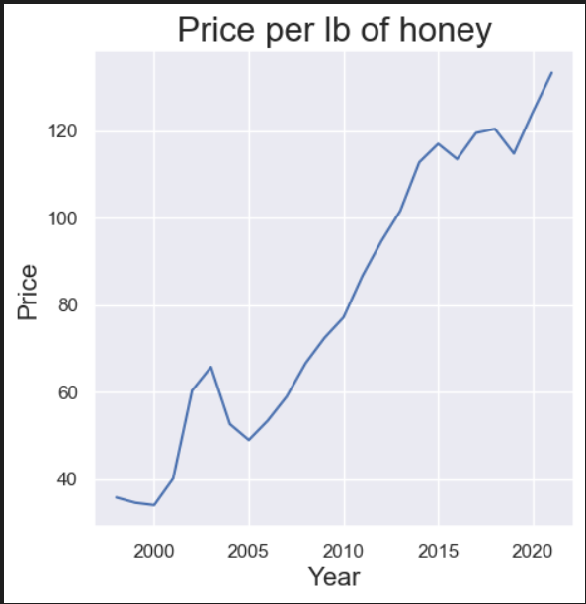

**We know that production has reduced from 1998 to 2021, but if demand remains constant, the price will rise, this can be seen in the graph above**